CCNA 3 Lab 1 – Network design

1. Your names: NAME 1, NAME 2, (NAME 3) (should be done in groups of 2-3 persons)

You are the IT management team of a company called Matti’s Miracle Makers (MMM). MMM is now moving to new location. The location consists of two buildings: a three-floor office building and a one-floor factory as shown below

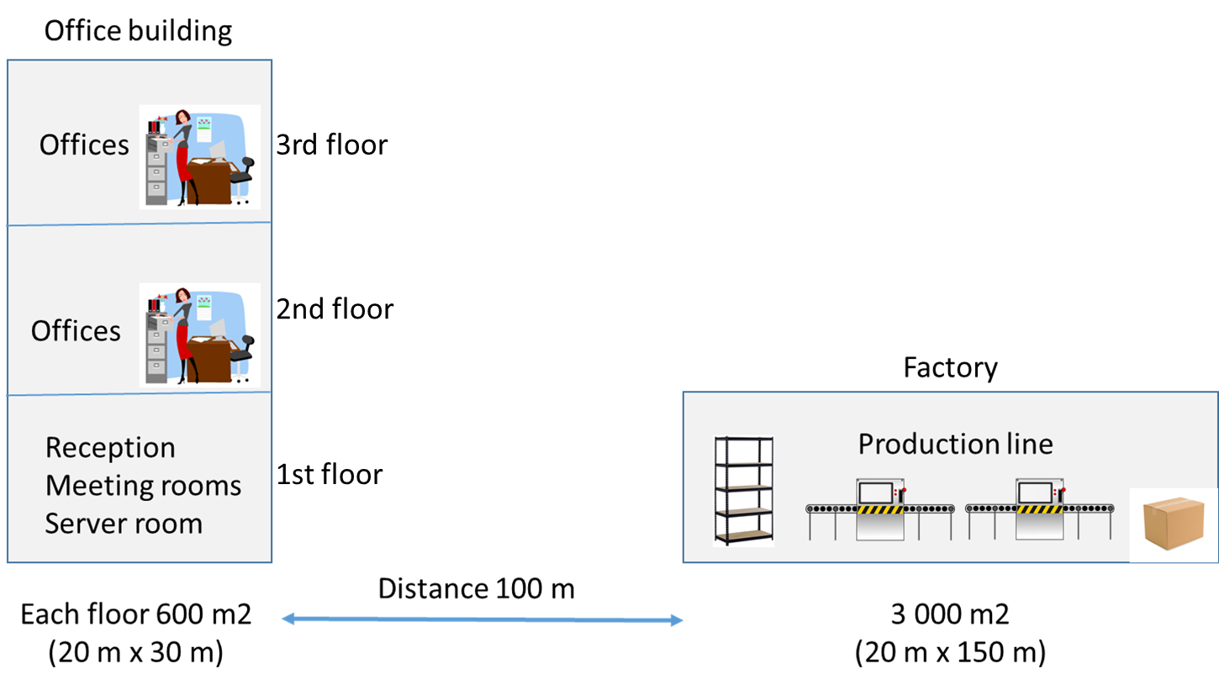

In the office building, the first floor has the reception desk, three meeting rooms and a server room. There are only two receptionist working full time in this floor. The second and the third floor both have 20 people working in their office rooms. In the factory, there are 20 network-connected devices, which are used in different tasks of the production (from component storage to different steps in production line and finally in warehouse of products waiting for shipping).

The organization has four different user groups: managers, an accounting team, a design and office team and a production team. The first three groups work in office building and the last one in factory.

1. Physical and logical network design (40 points)

Design a network topology for MMM’s new location in following steps:

1. **Physical topology**

Draw simple **floor plan** for the company (based on the description above, you can decide the details). Notice that based on current building regulations, it is recommended to have at least two network jacks per work place.

Where do you locate the wiring closets? Add them to the floor plans.

What kind of cables do you use and where? Add them to the floor plans (no need to draw every individual cable for the work place network jacks, but add some of them as examples).

1. **Devices**

What **types of devices** (router, switch, access point, firewall) do you place and **where**?

Draw a simple **logical topology** picture of your network, showing the connection types between the devices.

1. **IP addressing**

Create an **IP address plan** for the company. Your ISP has given you a class C address space of **197.7.7.0 /24**.

Add the needed IP addressing information to the logical topology picture.

Please provide your answer in a **form of drawings** (hand-drawn/computer-drawn pictures are both ok) and **attach the topology pictures to the next page of this document**.

**ATTACH YOUR PART 1 ANSWER (PHYSICAL AND LOGICAL TOPOLOGY) HERE AS PICTURES…**

1. Selecting the device models (30 points)

In part 1, you selected just the general device types (like router, switch etc.) Now it is time to **select the actual models** of the devices you are going to buy. You should also find out the **prices** for the devices you decided to use.

Fill the answer to the table below.

|  |  |  |  |  |  |
| --- | --- | --- | --- | --- | --- |
| **Device type**  (e.g. switch) | **Manufacturer and model** | **Locations**  (where are they used) | **Number of devices** | **Unit price** | **Total cost** |
|  |  |  |  |  |  |
|  |  |  |  |  |  |
|  |  |  |  |  |  |
|  |  |  |  |  |  |
|  |  |  |  |  |  |
|  |  |  |  |  |  |
|  |  |  |  |  |  |
|  |  |  |  |  |  |
|  |  |  |  |  |  |

What is the **total cost** of all the needed devices? **YOUR ANSWER**

Where did you find the prices of the devices? **Explain** and **copy-paste the links** below:

**YOUR ANSWER HERE**

1. Implementing the network with Packet Tracer (30 points)

Now you should implement the designed network in practice with Packet Tracer:

* Use **three different computers** (each computer runs Packet Tracer and connects over the real network)
* In computer 1 you will have the second floor of the office building
* In computer 2 you will have the first floor of the office building
* In computer 3 you will have the factory building

*(If there are only two students in a group you can skip the second floor of the office building if you want).*

Remember to implement **both physical and logical topology** in Packet Tracer! Use your own floor plans as a background image in the Physical Workspace.

Use the Packet Tracer **Multiuser connection** functionality to connect the computers together.

Explain shortly how did you implement the Packet Tracer Multiuser connection in practice:

**YOUR ANSWER HERE**

All devices should have the basic network configurations done (hostnames, IP addresses, routing). No need for security-related configurations in this task.

When ready, all the devices should be able to ping each other (also over the Multiuser connection between the physical computers).

1. Delivering your results

When you have done all the tasks, **upload your results to Moodle**. Remember to submit

* **This document**, with all the answers filled.
* **All Packet Tracer files** (two or three, depending on how many people were doing the task).

**One submission per group is enough**, no need for every group member to upload similar documents!